Chickens - Showmanship
Showmanship in poultry is an opportunity to show and tell the unique qualities of your bird and, your knowledge of poultry. Showmanship can also become a contest, and with most contests a way to hopefully pick up a few new facts.

Getting Your Animal Ready
Unlike raising your bird, getting your bird ready could arguably take just a few minutes. Wash their shanks (legs) using a wet wipe and elsewhere if needed. Some people use Vaseline, baby’s oil or Vet RX on their wattles and comb to make them ‘shine’. You may also want to trim their beak and claws (toenails) just trim them slightly though and, if needed. Granted some people give their birds a bath three days before the show as well, although showmanship is based more on your knowledge then the bird, it does show you care.

How to Bathe a Bird
- Get three tubs filled with Lukewarm water
- Put soapy water in the first, the second with a half cup of vinegar per five gallons of water (distilled (white) vinegar for light colored birds and apple cider vinegar for dark colored birds). The last is plain water.
- Dip the birds in the first tub, adding soap to the bird if necessary to clean dirty spots.
- You may also want to take an old tooth brush and scrub the legs and feet.
- Then dip in the vinegar water to cut the soapy reside and then last the water.
- Wrap them up in an old towel so they can dry off.
- You may also want to trim their toe nails or beaks slightly, just in case you would cut the quick.
Some people wear long sleeves to protect their arm from a nervous chicken trying to get away.

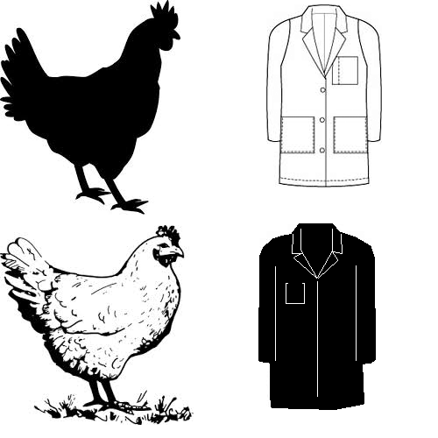
Getting Yourself Ready
Well this may not be the most ‘enjoyable’ step how you dress and your knowledge do effect your score. When ‘dressing up’ you will want to wear a white shirt for dark birds and, a black shirt for light birds to make them pop. Lab coats and long sleeved button-downs are preferred in both showmanship and with you showing birds in general, along with dark pants.

Next comes studying, it is advised to have a general idea of the breeds and, in particular yours. With what is and isn’t preferred, anatomy (body parts), breed characteristics as well as the history of the bird and, its breed. Some ‘common’ questions and ideas of what to study can be found to the left.
Common Questions
- What breed, class, gender and age is your bird?
- Why did you pick this breed?
- What did you do to get ready for the show?
- Can you tell me about your bird (history, body parts, to what areas you would like improve)?
- What are the disqualifications for your breed?

Showing Your Bird
Now, the moment has arrived, with both you and your bird are standing by your cage. In Showmanship, the judge will walk around the cages. Remember to stand up straight and, resist the urge to play with the bird or shavings. Follow the judge with your eyes, being careful to not block the cage and most importantly smile. When he or she comes up to you, introduce yourself and share briefly with the judge what you know about your bird. Start explaining the class your chicken is in and any history you know about the breed then ask if you may take your bird out of the cage (or the judge will instruct you to). Always remember to take the bird out of the cage head first and put the bird away head first, you don’t want to hurt their wings or break their feathers.
Show the judge the parts of your bird, the head, wings, back, tail, feet, naming any parts you can while you do. The judge may then hold your bird and ask you more questions. Smile, you worked hard for this moment so show off what you’ve learned. Then put the bird back in the cage head first.
The judge will then go to the next kid, but stay at attention, watching the judge. You shouldn’t slouch or play with the materials in the cages. This kind of judging ‘variety’ seems to be the most common, granted expect the unexpected and, most importantly, have fun!

