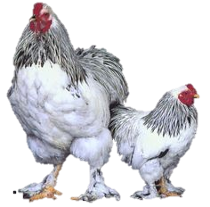
Chickens – Breeds, Varieties and Strains

Classes, Breeds, Varieties and Strains
A Class is a group of chickens that share a similar origin or appearance.
- Bantams are classed off of their physical traits.
- Standards are classified based on where they originated.
A Breed is a group of chickens that share a similar body conformation. Where a Variety can be a color or a different comp type amongst other features. Strains are families within a breed with differences between the birds; a good example would be the numerous Leghorn strains in the commercial industry.
The late 1800’s to the mid 1900’s was were most breeds were developed as importance was based on one bird versus the commercial industry where the flock average was judged. Exhibition breeders continually look for other bloodlines to improve their flock.

Large Fowl versus Bantams
Large Fowl are the full sized chickens in the poultry world where bantams are usually ¼ the size of Large Fowls and are simply miniatures, sharing the same physical characteristics as the standards with a weight difference. Many bantams have a large counterpart , however those that don’t are called true-bantams.

Classes
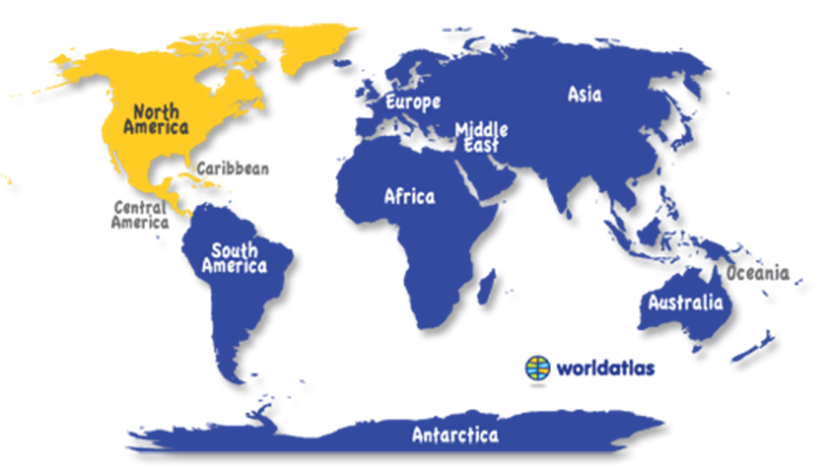
Six classes exist for Large Fowl and five classes for Bantams.

The Continental Class
Northern European
- Hamburgs
- Campines
- Lakenvelders
Polish
- Polish
French
- Houdans

- Faverolles

- Crececours

- La Fleche

The APA Book of Standards is an excellent resource that describes what to look for in many breeds.
All Other Standard Breeds
Games
- Modern Games
- Old English Games
Orientals
- Sumatras
- Malays
- Cubalayas
- Phoenix
- Yokohamas
- Assel
- Shamos
Miscellaneous
- Sultans
- Naked Necks
- Araucanas
- Ameraucanas

• Orpingtons
• Sussex
• Austrolorp
The English Class
- Dorkings
- Redcaps
- Cornish

The Mediterranean Class
- Leghorns
- Minorcas
- White Faced Black Spanish
- Andulusions
- Anconas
- Siclian Buttercups
- Catlana’s

The Asiatic Class
The fowl in this class all have feathered shanks.
- Brahmas
- Langshans
- Cochins

The American Class
Most fowl in this class are hardy dual purpose breeds.
- Plymouth Rocks
- Dominiques
- Wyandottes
- Javas
- Rhode Island Reds
- Rode Island Whites
- Buckeyes
- Chanteclers
- Jersey Giants
- Lamonas
- New Hampshires
- Hollands
- Delawares

